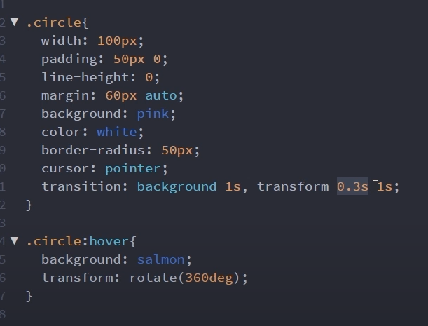

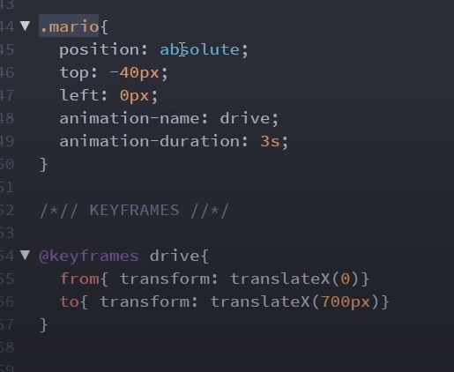

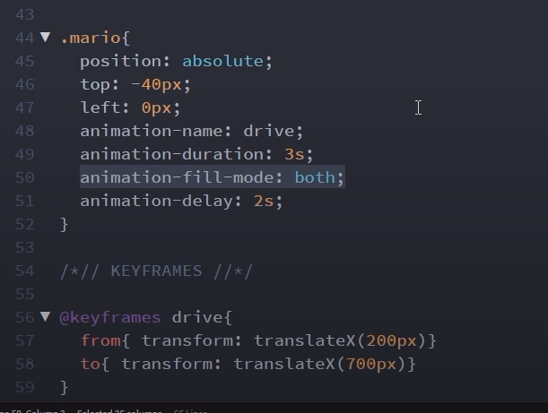

forwards – the animation stays in its final position (700px else after animation was ended it would pop back to its starting position)

backwards – the animation begins from 200px instead of 0 position (original position how CSS was written for it) after reload the animated object will already be at 200px instead of 0px.

Both – we get benefit of both forwards and backwards.

animation-iteration-count: infinite ( or can be any integer)

animation-direction: reverse ( or normal or alternate-reverse or alternate)

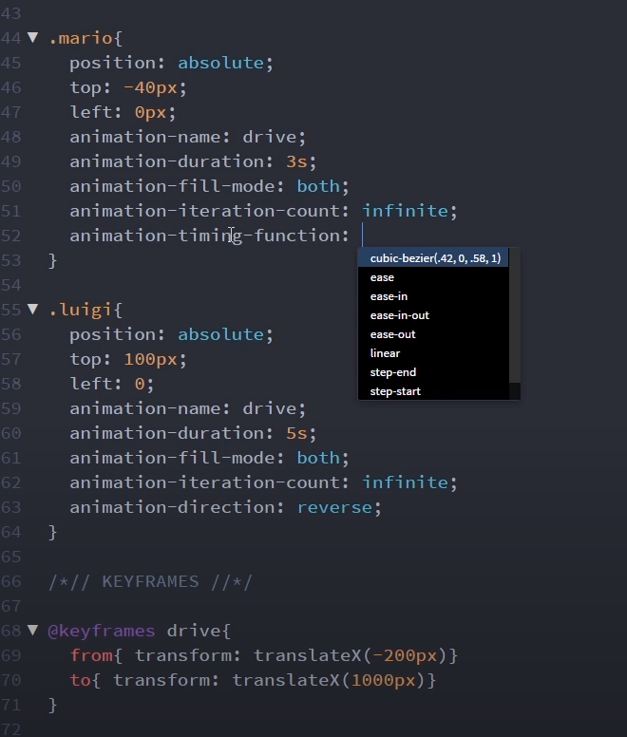

Cubic-bezier.com

**SHORTHAND**

animation: name duration timing-function iteration-count animation-fill-mode

delay should be always come after duration and can be written anywhere in short hand property

apart from this any property can be anywhere

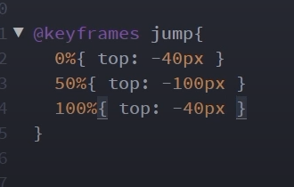

Chaining animation

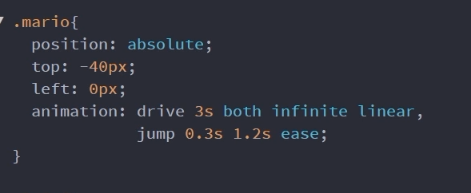

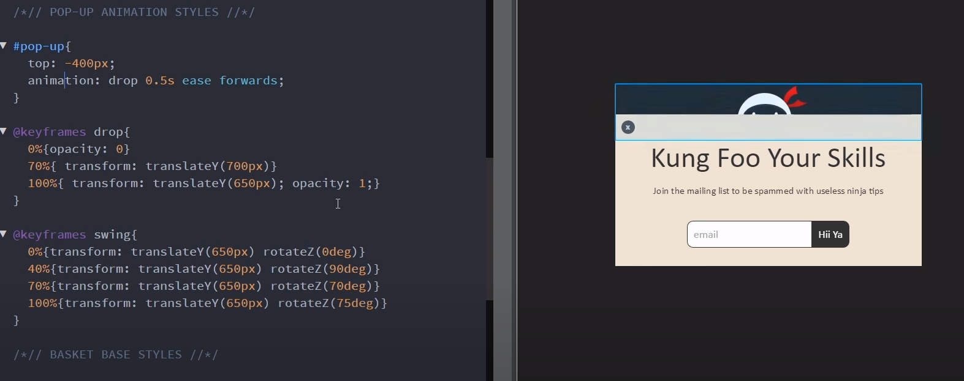

We need to keep on giving previous animation so we don’t override it

To change origin of rotation we can give transform-origin property

Transform-origin:10px 10px

Or transform origin: top bottom left right center